MEMORIES LIFO/FIFO

OBJECTIVE
This lab aims at acknowledging students with the concepts of commonly used data organization structures such as LIFO, FIFO and dual-port memory. At the end of this lab, students should be able to design their own implementation for these modules in system Verilog and verify their functionality using test-bench simulations. Additionally, porting the memory designs on FPGA will be an added plus.

TOOLS & LANGUAGE
- Xilinx Vivado 2019.1
- Verilog / System Verilog (SV)

INTRODUCTION
LIFO, which stands for Last In, First Out, is a data organization method commonly used in digital design and computer science. The LIFO principle dictates that the most recently added item is the first one to be removed. This concept is analogous to a stack of plates, where the last plate placed on top is the first one to be taken off.
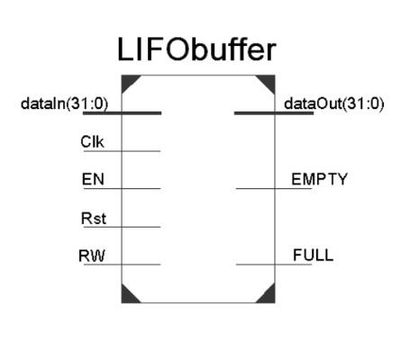
LIFO Block
LIFO is the fundamental principle behind the stack data structure:
- New elements are added to the top (push operation)
- Elements are removed from the top (pop operation)
- The most recently added element is always at the top
LIFO is used in various aspects of memory management and program execution, but is most often used for function calls. When a function is called, its parameters and return address are pushed onto a stack. When the function returns, these values are popped off.

ASYNCHRONOUS FIFO

An asynchronous FIFO refers to a FIFO design where data values are written to a FIFO buffer from one clock domain and the data values are read from the same FIFO buffer from another clock domain, where the two clock domains are asynchronous to each other. The write pointer always points to the next word to be written; therefore, on reset, both pointers are set to zero, which also happens to be the next FIFO word location to be written. On a FIFO-write operation, the memory location that is pointed to by the write pointer is written, and then the write pointer is incremented to point to the next location to be written.
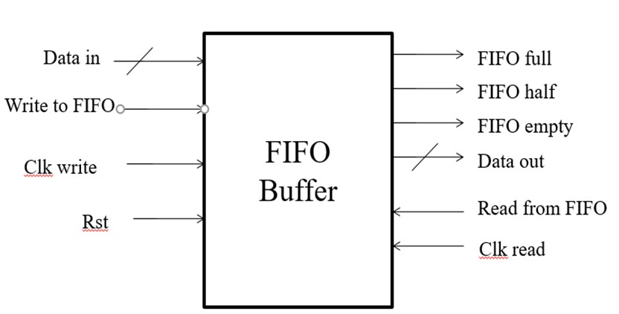
Asynchronous FIFO
Similarly, the read pointer always points to the current FIFO word to be read. Again, on reset, both pointers are reset to zero, the FIFO is empty and the read pointer is pointing to invalid data (because the FIFO is empty and the empty flag is asserted). As soon as the first data word is written to the FIFO, the write pointer increments, the empty flag is cleared, and the read pointer that is still addressing the contents of the first FIFO memory word, immediately drives that first valid word onto the FIFO data output port, to be read by the receiver logic.
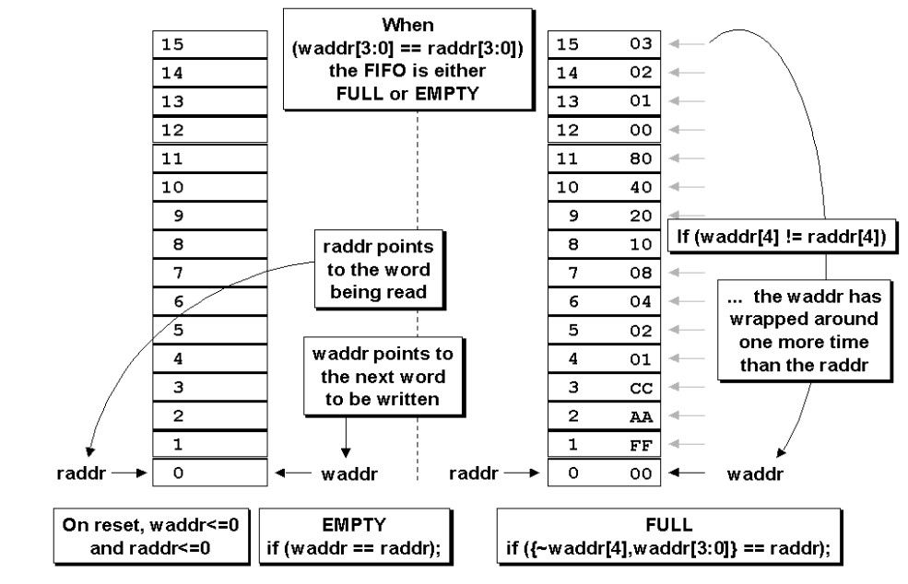
FIFO Full & Empty conditions
The FIFO is empty when the read and write pointers are both equal. This condition happens when both pointers are reset to zero during a reset operation, or when the read pointer catches up to the write pointer, having read the last word from the FIFO. A FIFO is full when the pointers are again equal, that is, when the write pointer has wrapped around and caught up to the read pointer. This is a problem. One design technique used to distinguish between full and empty is to add an extra bit to each pointer. When the write pointer increments past the final FIFO address, the write pointer will increment the unused MSB while setting the rest of the bits back to zero.
Using n-bit pointers where (n-1) is the number of address bits required to access the entire FIFO memory buffer, the FIFO is empty when both pointers, including the MSBs are equal. And the FIFO is full when both pointers, except the MSBs are equal.

LAB TASKS

TASK1: LIFO
For this task, you are required to write the standard system Verilog implementation for a synchronous LIFO buffer. The module should be parametrized with WIDTH and DEPTH parameters. LIFO read operation should be asynchronous. To test your module, simulate your design by writing a test-bench. For clock, assume a 100MHz frequency.
PUSHING AND POPPING DATA
• For pushing data, read = 1 so data is driven onto the data_out bus
• For popping data, keep read = 0 during the operation
• Continue popping until empty flag = 1
• Empty flag indicates stack/LIFO buffer is empty
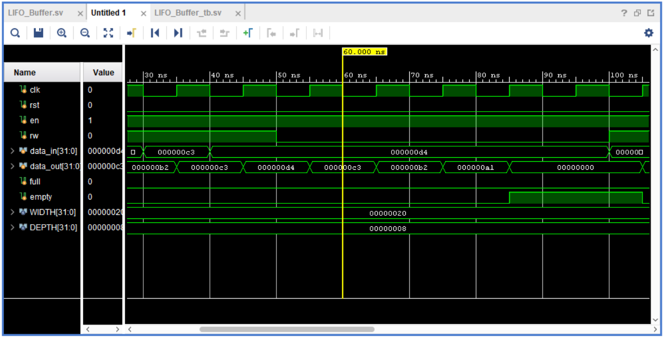
• Data appears on output in Last-In First-Out (LIFO) order

PUSHING DATA AND SEEING FULL LIFO/STACK
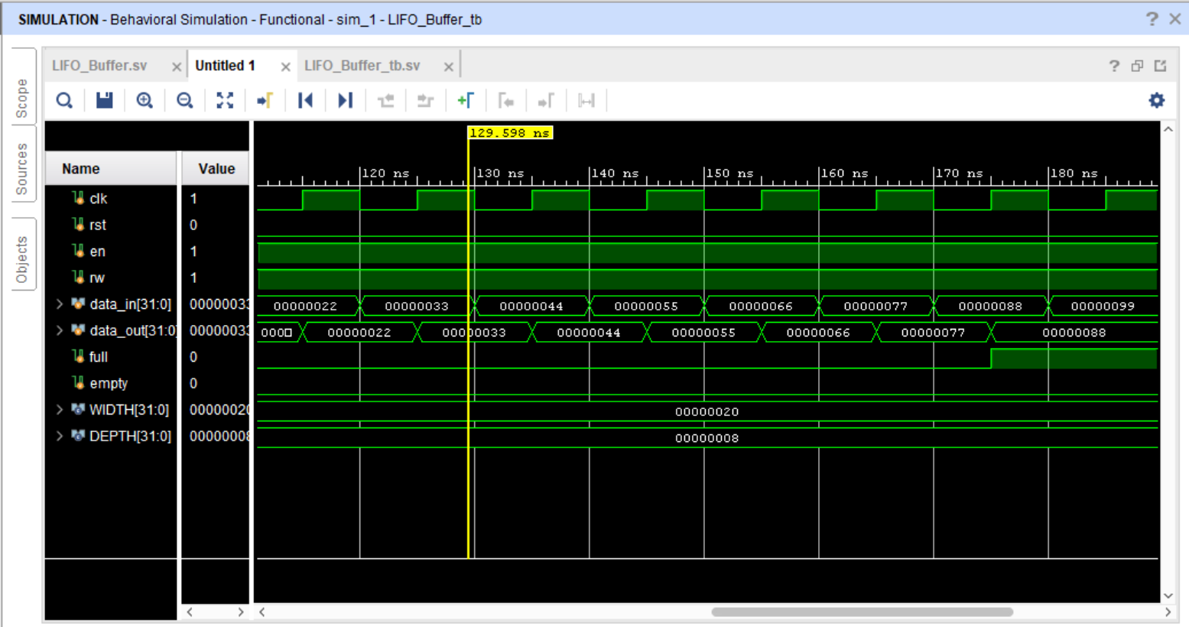
Continuously pushing data so that the stack full flag gets high.

ELABORATED DESIGN
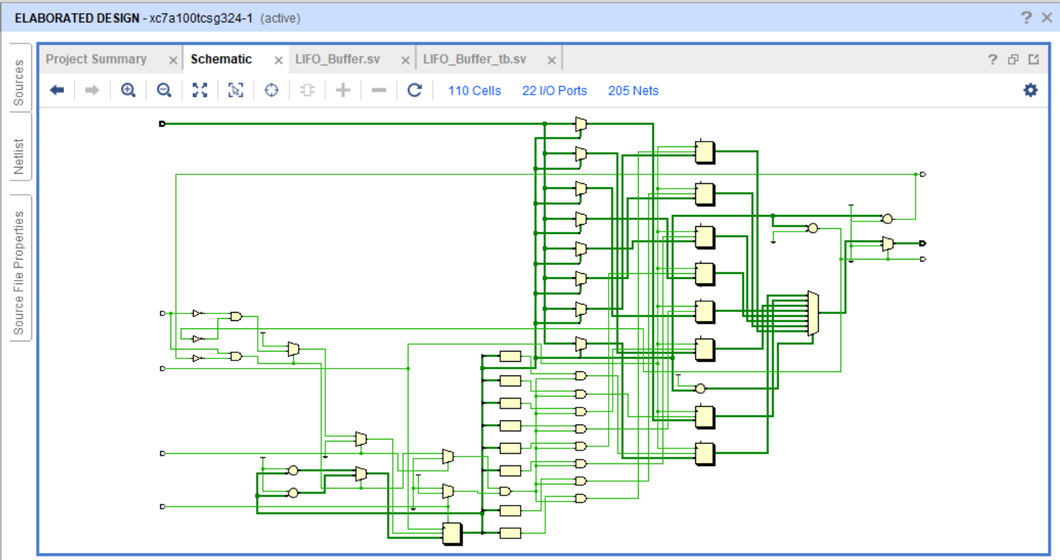

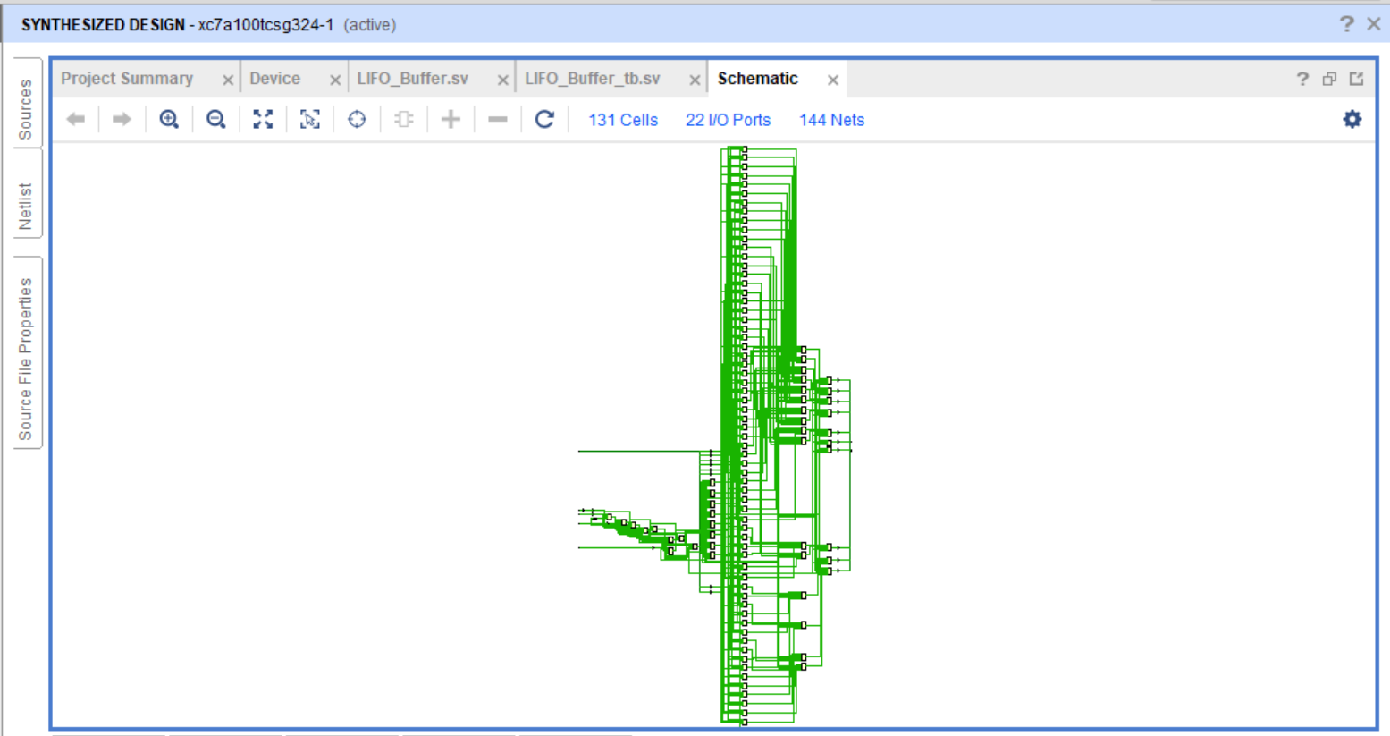
SYNTHESIZABLE DESIGN

TASK2: FIFO
Create an asynchronous FIFO with separate read and write clock signals alongside asynchronous resets. Write operation must be clocked, whereas the read can be performed asynchronously. Ensure the FIFO read/write pointers are incremented w.r.t their clocks. Choose arbitrary frequencies in MHz for simulation purposes.
FIFO READING AND WRITING AT THE SAME TIME
- Read and write clocks are different (asynchronous clocks).
- Read and write operations occur simultaneously in the waveform.
- Demonstrates true independent dual-port operation.
- No interference observed between read and write processes.
- Internal signals (like read/write pointers or address lines) help clearly track operations.
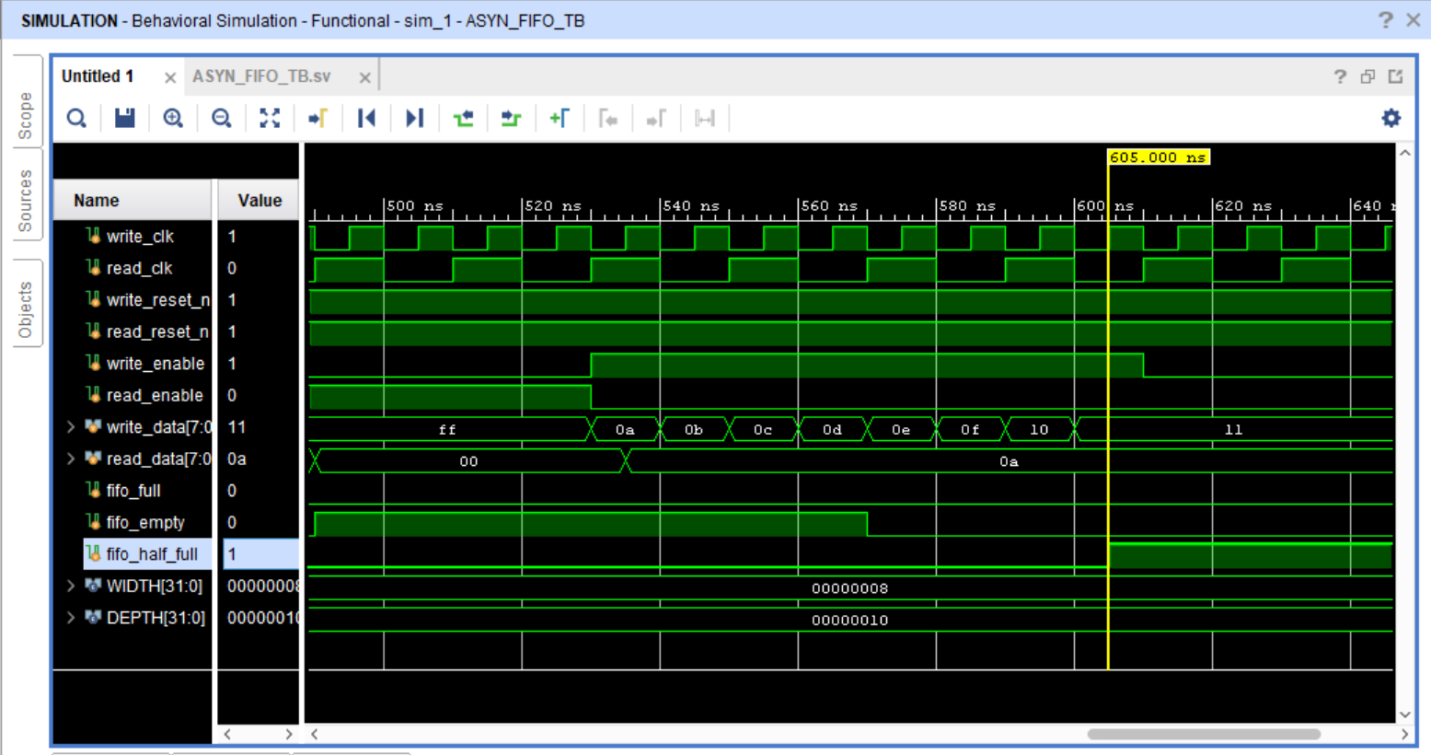
- Using these internal signals makes the waveform easier to understand and debug.

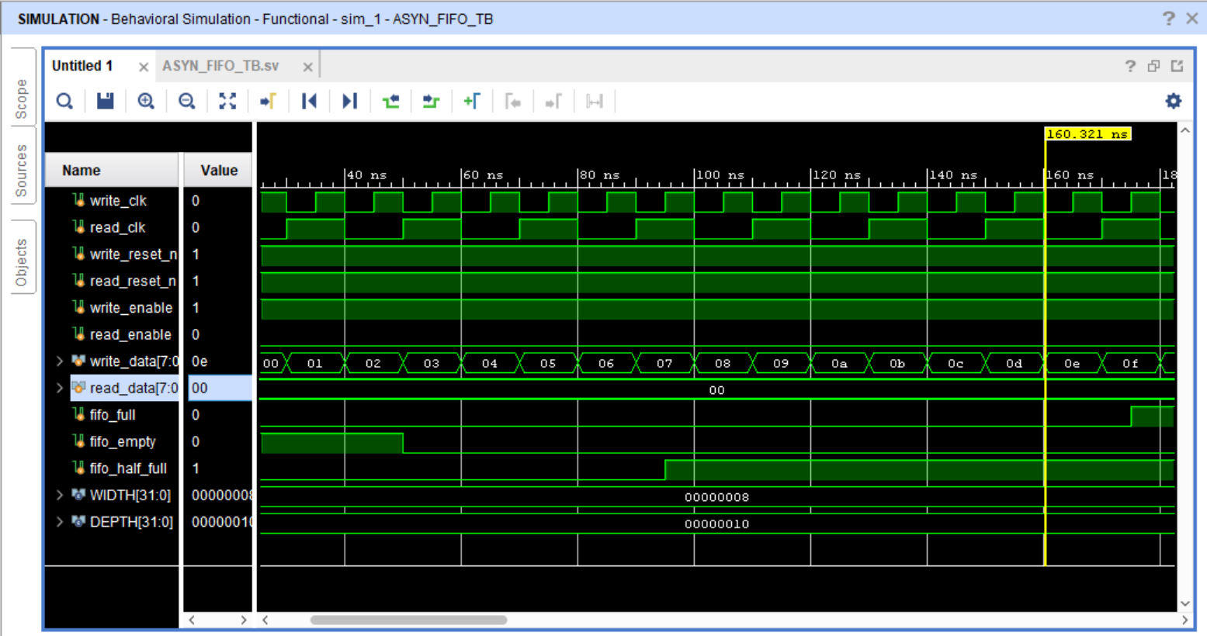
FIFO: WRITING DATA

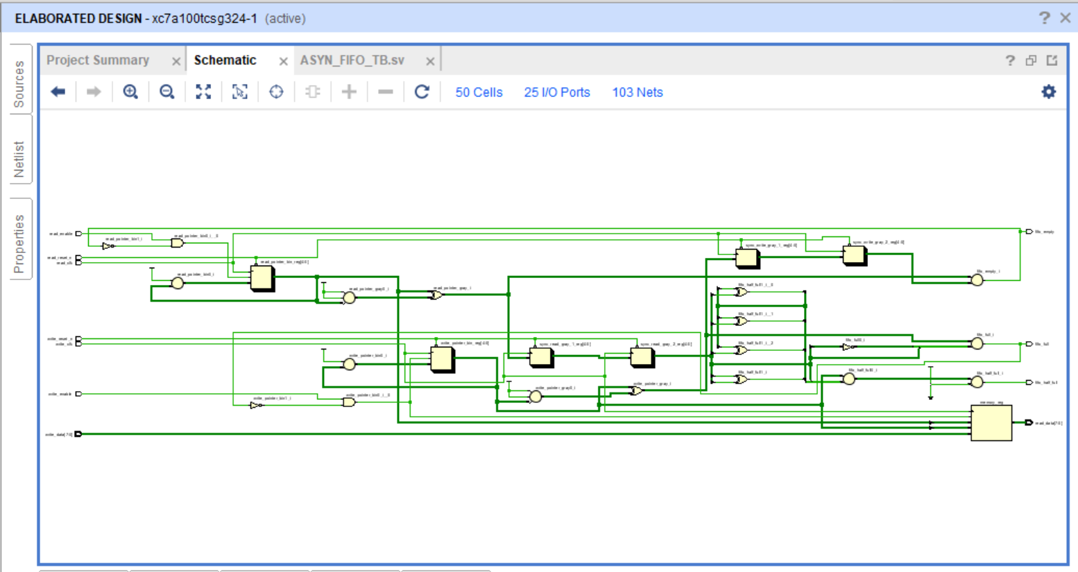
ELABORATED DESIGN
SYNTHESIZABLE DESIGN
